**PROJECT DESCRIPTION**

**OVERVIEW**

~~Ecosystems worldwide are experiencing strong perturbations from habitat loss and climate change. Such perturbations are causing the extinction of species and collapse of ecological communities. To understand the stability of ecosystems requires understanding the interactions between species. Traditionally, an ecosystem is conceived as a network of species with fixed interaction strengths. A classic example is a food web of trophic interactions, where the rates of pairwise interactions depend on the population densities with fixed parameters. Such models of species interactions ignore the plasticity and heterogeneity of traits within a population that can affect how individuals interact with others. For example, habit loss has forced organisms to change their behavior and form new patterns of species interactions. As a result, the interaction strengths between species should not be treated as constant. While there are models of ecosystems that consider the dynamics of specific traits, there is a lack of systematic study on the consequences of dynamic interaction strengths. We propose to study a general framework where the interaction strengths depend on the distribution of traits within a population, and this trait distribution may shift under the influence of other species. Such trait shifts effectively result in the modification of interaction strengths between species. There is a gap in understanding how such trait-mediated interaction modification will affect the stability of ecosystems and the persistence of species.~~

The stability of ecosystems is affected by both natural and, increasingly, human factors that affect the component species directly but also indirectly due to the complex species interactions within the ecosystem. Most theoretical work on these interactions models them as a network of pairwise species interactions that drive variation and covariation in species abundances due to fixed interaction parameters. Although this is convenient and has produced many important insights, it ignores the possible intraspecific variation in how individuals participate in these interactions due to variation in their ecological traits. As such, interactions are not necessarily fixed because they can vary as the trait distributions change depending on local community context (environment and/or occupancy by other species). Although a number of examples illustrate the significance of thus trait-mediated changes in species interactions (see below), there remains a large gap in understanding how such trait-mediated interaction modification will affect the stability of ecosystems and the persistence of species.

Mathematically, trait shifts give rise to dynamical systems where the interaction strengths between species can change over time. Our preliminary results have shown that these dynamical systems will exhibit new types of behavior, such as the emergence of new attractors, the introduction of new timescales, and the appearance of new dynamics (such as hybrid systems, Jackson & Xue 2022). Thus, it is of mathematical interest to analyze such special dynamical systems. For simple systems with a few species, such as three-species competitions, previous work has shown that there is a limited number of possible structures for the equilibrium (Zeeman 1993). In particular, the existence of multi-species equilibrium is determined by the qualitative behavior of two-species subsystems. However, it has been shown that these rules will be violated if the interaction strength between two species can be modified by the third species, leading to higher-order interactions (Friedman et al. 2017). Such interaction modification can result from dynamic shifts in population composition, which is known to cause emergent properties that are counterintuitive (de Roos 2020). It remains to be studied what equilibrium structures are possible when dynamic trait shifts and the resulting interaction modifications are considered.

The main goal of this project is to identify patterns of trait-mediated interaction modification (TMIM) that would lead to ecological outcomes unpredicted by models without TMIM. We will study TMIM by both analyzing mathematical models and synthesizing empirical evidence. Our Specific Aims include:

1. Constructing network motifs of TMIM, outlining the equilibrium structures of the motifs, and identifying conditions that would contradict the results from previous analyses without trait shifts.
2. Performing a survey of empirical studies for known examples of TMIM, categorizing them according to our list of motifs, and evaluating the evidence for TMIM in those examples.
3. Scaling up the analysis to large networks, constructing “trait-structured models” using the motifs, and analyzing the stability of highly diverse ecological communities in the presence of TMIM.

Our work will generate a framework to systematically categorize network structures of species interactions in the presence of TMIM. Given this framework, we will be able to collect evidence from empirical studies to gauge the prevalence of each network motif. Our analysis of large ecological networks will help elucidate how intraspecific trait variations and their dynamics will affect the stability of ecosystems and the persistence of species, and possibly identify shortcomings in our theoretical approach. By incorporating trait structure of populations in modeling ecological communities, our approach will enable improved prediction on the outcome of community assembly or restructuring, such as due to invasive species, extinctions, and habitat, or climate change. The project will train a postdoc and a graduate student in the interdisciplinary area between mathematics and ecology. As part of the broader impacts, we will create an experimental kit for use in K-12 classrooms that teaches important ecological concepts, and will organize a workshop for teachers’ development to demonstrate the kit.

**BACKGROUND AND SIGNIFICANCE**

Trait-Mediated Interaction Modification in Ecology:

An ecosystem is formed by interactions among many organisms. In the burgeoning literature on analyses of communities as networks of interactions among multiple species (e.g., Delmas et al., 2019, Dale & Fortin, 2021, Dormann et al., 2017, Guimarães, 2020), interactions as represented by links in networks are typically considered to depend only on species abundances and given species traits, irrespective of context, and the network pattern of these interactions is fixed. This picture is unfortunately too simplistic, as the trait of an organism is not only determined by its genotype, but also its environment, including abiotic factors and other organisms it encounters. Such phenotypic plasticity is expected when there are reliable cues about an environment varying over time or space (Scheiner, 1993, Schmidt et al., 2010). Evolutionary ecologists have long argued that plasticity can lead to shifts in interspecific interactions (Agrawal, 2001, Scheiner et al., 2015). Berg & Ellers (2010) argued that plastic responses in a focal species might make it superior in competition with other, non-plastic species, precluding coexistence; Callaway et al. (2003) by contrast argued that plasticity in plants tailored to specific neighbor species can facilitate coexistence, for instance via shift in rooting zones. Turcotte & Levine (2016) suggested that “no study [currently quantifies] the net effect of plasticity on species coexistence.” One consequence of plastic responses is that it can generate individual variation within populations. This can result from responses to heterogeneous micro-environments, or stochastic cellular processes. Existing theoretical studies have given contrary expectations about the consequences of such intraspecific trait variation. On the one hand, given nonlinear averaging, species coexistence may be made more difficult (Hart et al., 2016); on the other hand, moderately heritable phenotypic variation appears to stabilize Lotka-Volterra dynamics (Maynard et al., 2019).

A realistic biological complexity that is left out of most such analyses is that an interaction between two species comprising a link in the network can be strongly influenced by the presence and activity of additional species (e.g., Golubski & Abrams, 2011). Ecologists are becoming increasingly aware that network analyses need to account for such effects, often under the rubric of trait-mediated indirect interactions (Ohgushi et al., 2012, García-Callejas et al., 2018). (Terry et al., 2017, 2020) argued that incorporating non-trophic interactions explicitly into functional responses and other mechanistic components of population models (as in Holt & Barfield, 2013) permit one to ask fresh questions about how ecological complexity influences ecosystem stability. Interaction modification, such as when one species induces a trait shift in a second species that affects how it interacts with a third species, can lead to higher-order interactions involving all three species. It has been argued that higher-order interactions are common in ecosystems (Mayfield & Stouffer, 2017), yet there have not been good models for the mechanistic basis of such interactions (Levine et al., 2017). To make theoretical advances, we will use simplified models of TMIM to study such higher-order interactions.

Mathematical Results on the Stability of Ecosystems:

The stability of ecosystems has been traditionally studied using Lotka-Volterra-type models. Many patterns of species interactions have been studied, such as exploitative competition (two predators sharing one prey), apparent competition (two prey having the same predator), trophic cascade (food chain), and mutual competitions (Fig.4). As a dynamical system, each interaction pattern results in certain types of equilibria that are characteristic of the pattern. For example, in exploitative competition, the two predators cannot coexist because generically the stable equilibria are those where the density of at least one predator goes to zero (Fig.X). In general, the structure of the equilibria depends on the value of the interaction strengths. Nevertheless, strong mathematical conditions have been found that constrain the possible types of stable equilibria. In particular, (Zeeman 1993) studied competitive 3-species Lotka-Volterra systems and derived a list of 33 classes of stable equilibria (Fig.X). Importantly, the existence of an interior equilibrium with all 3 species present is largely determined by the behavior of 2-species subsystems, i.e., the edge configurations. These rules are robust for different values of interaction strengths, as they are derived using topological analysis irrespective of the parameter values. A picture containing engineering drawing
These analyses have been extended to more species, more general dynamic equations, and non-competitive interactions (Zeeman & Zeeman 2002, Jiang & Niu 2017, Gyllenberg et al. 2020, Baigent & Ching 2020).

However, these results assume fixed interaction strengths throughout the dynamic processes. When interaction strengths are themselves dynamic, as can be caused by TMIM, the rules will be violated. Indeed, ecosystems can be a special type of dynamical systems whose interactions are plastic, unlike simple physical systems where the interaction strengths are determined by fundamental forces. It is well known in physics that changes in interactions can lead to emergent properties on the systems level, such as phase transition between ordered and disordered states. Following this analogy, it is important to examine whether TMIM will lead to the (de)stabilization of ecosystems. Indeed, interaction modifications effectively cause higher-order interactions among several species. Experiments in microbial communities (e.g., Friedman et al. 2017) have shown that such higher-order interactions may lead to outcomes that contradict the rules derived in previous mathematical analyses that assumed pairwise interactions (Fig.X).

Beyond small ecosystems with a few species, the stability of large ecological networks has been studied using statistical approaches (Wilson et al., 2003, Rossberg, 2013). Such models consider the pairwise interaction strengths among a large number of species as being drawn randomly from a statistical distribution. A classic example is (May, 1972), which derived the mathematical condition for a system to be stable in terms of the variance of interaction strengths. More recent work has studied the persistence of species and its dependence on the network structure (Barbier et al., 2018), as well as community assembly from a large species pool (Servan et al., 2018). Such analyses have been extended to incorporate the spatial structure of populations, which was shown to enhance the stability of meta-communities (Gravel et al., 2016). More recent theoretical work has considered higher-order interactions among multiple species using similar statistical approaches (Bairey et al. 2016, Mayfield & Stouffer 2017, Grilli et al. 2017, Letten & Stouffer 2019, Kleinhesselink et al. 2022). However, these models did not provide insight on the mechanisms by which the higher-order interactions may arise (Levine et al., 2017). We will fill this gap by considering specific motifs of TMIM that can result in higher-order interactions.

Significance and Merits:

Figure 2: Schematic for identifying higher-order interactions in coexistence patterns (adapted from Friedman et al. 2017). Left: Trios of species are cultured together in all pairwise combinations to determine pairwise effects and then grown together to quantify deviations from expected. Right: possible outcomes are either consistent with predictions (no qualitatively important HOIs) or not (and thus indicate that HOIs have qualitative effects on coexistence).

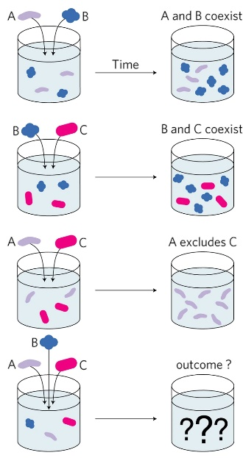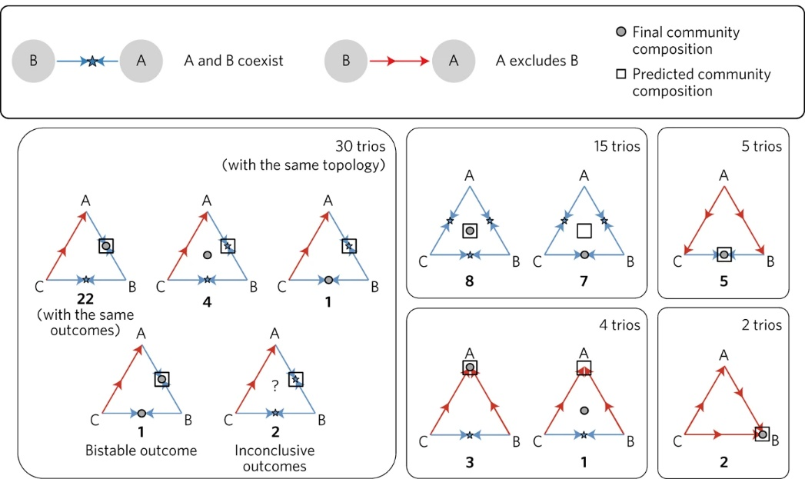

The stability of ecosystems is an urgent problem due to the rapid change of environment for the species. For example, climate change leads to migration of many species and forges new interactions between species. Understanding how species interactions are modified is key to being able to predict the ecological outcomes, such as the survival of endangered species and the effects of invasive species. The basic science of trait plasticity and how it alters species interactions is an important problem in biology. Recognizing the importance of phenotypic plasticity in adaptation and evolution is a major theme in the rapidly developing field of eco-evolutionary biology. Understanding how such plasticity has large-scale consequences on ecosystems will be a significant contribution to the field. As ecological studies start to incorporate large scales and big data, a quantitative, statistical approach is in order.

**Our proposal directly addresses the stated goal of the Mathematical Biology program** of developing “mathematically innovative” work while simultaneously “address challenging problems of interest to members of the biological community”. [mathematical significance: systematic study of motifs, empirical evidence, etc.]

Our team is well prepared for undertaking the proposed research. Both the PI BKX and Co-PI RDH have studied phenotypic plasticity and its evolutionary significance (e.g., Xue & Leibler, 2018, Scheiner et al., 2020). Such plasticity is closely related to trait-mediated indirect effects, i.e., how trait changes result in interaction modifications, an emerging subject in ecological studies. Co-PI RDH, who co-edited a book on this very subject (Ohgushi et al., 2012), offers expertise on ecological theories and examples of trait changes and their effect on species interactions. This will be complemented by the PI BKX’s systems biology approach to classifying network motifs involving trait-mediated interaction modifications. Such motifs can lead to macroscopic consequences on large networks, similar to the emergence of long-range order in statistical physics models. A “disordered systems” approach has been applied to studying the stability of large ecosystems, albeit without TMIM. Co-PI MAL has used such statistical modeling to study the stability and species co-distributions of meta-communities (Gravel et al., 2016). His expertise with this approach, combined with BKX’s expertise in statistical physics modeling, will allow us to develop a framework for incorporating TMIM into statistical models of ecological networks.

**RESEARCH PLAN**

**Aim 1: Analyzing network motifs of trait-mediated interaction modifications.**

Our goal is to identify different motifs of species interactions that contain interaction modifications, and characterize the equilibrium structure of these dynamical systems. We will find conditions under which new stable equilibria emerge that are not possible without interaction modifications, thus generalizing the stability conditions derived in previous analyses. We will build on recent conceptual and theoretical studies that have begun to explore impacts of individual variation on interactions (Bolnick et al., 2011, Hart et al., 2016 for direct competition models, Barabás & D’Andrea, 2016 for MacArthur style models, Steinmetz et al., 2020 for fluctuating environments, Hausch et al., 2018 for an empirical result). This prior work has largely considered either consistent fixed differences between individuals that are not heritable or heritable genetic variation. Plasticity can include variation in traits over the lifetime of an individual, and the models we will explore will have this dimension of individual variability as well.

Approach:

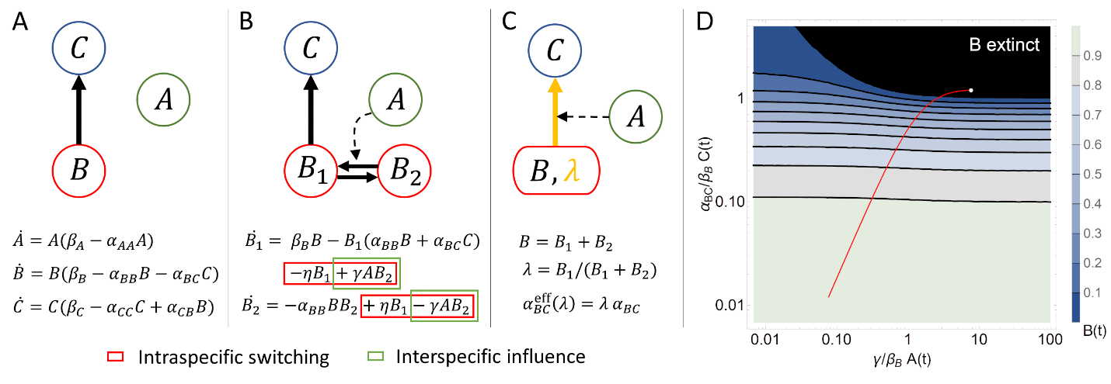Our main assumption is that there is a distribution of trait values within a species, and this distribution can be dynamic under the influence of other species. The interaction strength between the species will depend on the trait distribution. To simplify mathematical analysis, we will start from a simple form of trait variation, where the trait of each individual can be one of two types (dimorphism). Thus, there are two subpopulations within the species, which can exchange a flux of individuals, such as when individuals can switch phenotypes during their lifetime (e.g., behavioral traits) or can give birth to individuals of the other type (e.g., inducible defense traits). Importantly, the subpopulations can have different interaction strengths with other species (Fig.1B). If we course-grain such a heterogeneous population, using its total population as a dynamical variable like in a traditional Lotka-Volterra model (Fig.1A), then the effective interaction strength will depend on the ratio of the subpopulations (Fig.1C). Because this ratio can change over time due to different reasons, such as preferential consumption by the predator or plastic response to the environment and other species, the effective interaction strength can be dynamically modified.

Figure : Intraspecific trait variation can modify interspecific interactions. (A) Three species modeled by traditional Lotka-Volterra equations. Species A grows by itself, species B is consumed by species C, and all have direct density dependence. (B) Species B has intraspecific variation, modeled by two subpopulations, B1 and B2, which differ in interactions with the other species. All B individuals are born as B1, which is predated by C, and can switch to the refuge type B2. The equations for B1 and B2 have switching terms (red box), which are not of the Lotka-Volterra form; e.g., the B2 equation has a term proportional to B1 but not B2. The transition from B2 to B1 is facilitated by A, as represented by the term proportional to both A and B2 (green box), which is also non-Lotka-Volterra. (C) Changing variables from the subpopulations B1 and B2 to the total population B and the relative proportion . This variable would be “hidden” in a coarse-grained model with only B as a variable. Changes in will affect the effective interaction strength between B and C. Since A facilitates the switching between B1 and B2, depends on A. Thus, A modifies the interaction between B and C, leading to a higher-order interaction among all three species. (D) Bacteria abundance (B) as a function of algae (A) and ciliates (C) in the model described by Figure 1B. The x-axis is proportional to the abundance of A and the facilitation strength . The y-axis is proportional to the abundance of C and its feeding rate on B1, (it is assumed that is negligible due to a low yield of ciliates from consuming bacteria). Since the bacteria growth rate is much faster than algae and ciliates, B can be approximated to be at its equilibrium value given the instantaneous values of A and C. The color scale represents the equilibrium value of B. The black region is where the bacteria will go extinct. The red line is a trajectory of the population dynamics of the system, and the white dot is the final state. In this case, B goes extinct due to the presence of A. If A were not present (along the y-axis), B would be able to coexist with C.

Figure : Network motifs of trait-mediated interaction modification that give rise to higher-order interactions between three species. Left: Motifs derived from basic trophic interactions. Right: Motifs based on competitive interactions. (First row) Traditional motifs without intraspecific trait variation. (Second row) By adding phenotypic switching to one of the species, splitting it into two subpopulations, and letting another species influence the switching rates, we found 10 new motifs for trophic interactions and 4 for competitions. Blue double arrows represent intraspecific switching between subpopulations. Red dotted arrows represent interspecific influence on switching rates. (Third row) Coarse-graining the subpopulations results in the modification of an interspecific interaction by a third species, which gives rise to a higher-order interaction among all three species. Orange arrows represent interaction modification.

Although TMIMs have been studied in a few ecological examples (refs), there lacks a theoretical framework for classifying different patterns by which the interactions are modified. We will provide such a framework by systematically constructing *network motifs* of TMIM. The simplest examples involve three species, which may already form different interaction patterns in the absence of trait-mediated effects (Fig.2 top row). For example, one predator feeding on two prey species forms an “apparent competition”, and two predators competing for one prey forms an “exploitative competition” (Schoener & Spiller, 2012). On top of these patterns, we may consider trait variation and dynamic shifts within any of these species. Such trait shifts within one species can also be influenced by another species. This leads us to a table of basic motifs for trait-mediated interaction modifications (Fig.2 middle row). We will consider both trophic interactions (Fig.2 left panel) and competitive interactions (right). Mathematically, competitive interaction between two species affects both species symmetrically (both with negative signs), as opposed to trophic interaction that has opposite effects on the predator (positive) and prey (negative). This distinction makes competitive interactions easier to analyze (Zeeman 1993, Baigent & Ching 2020), which will be relevant for the disordered systems approach in **Aim 3**.

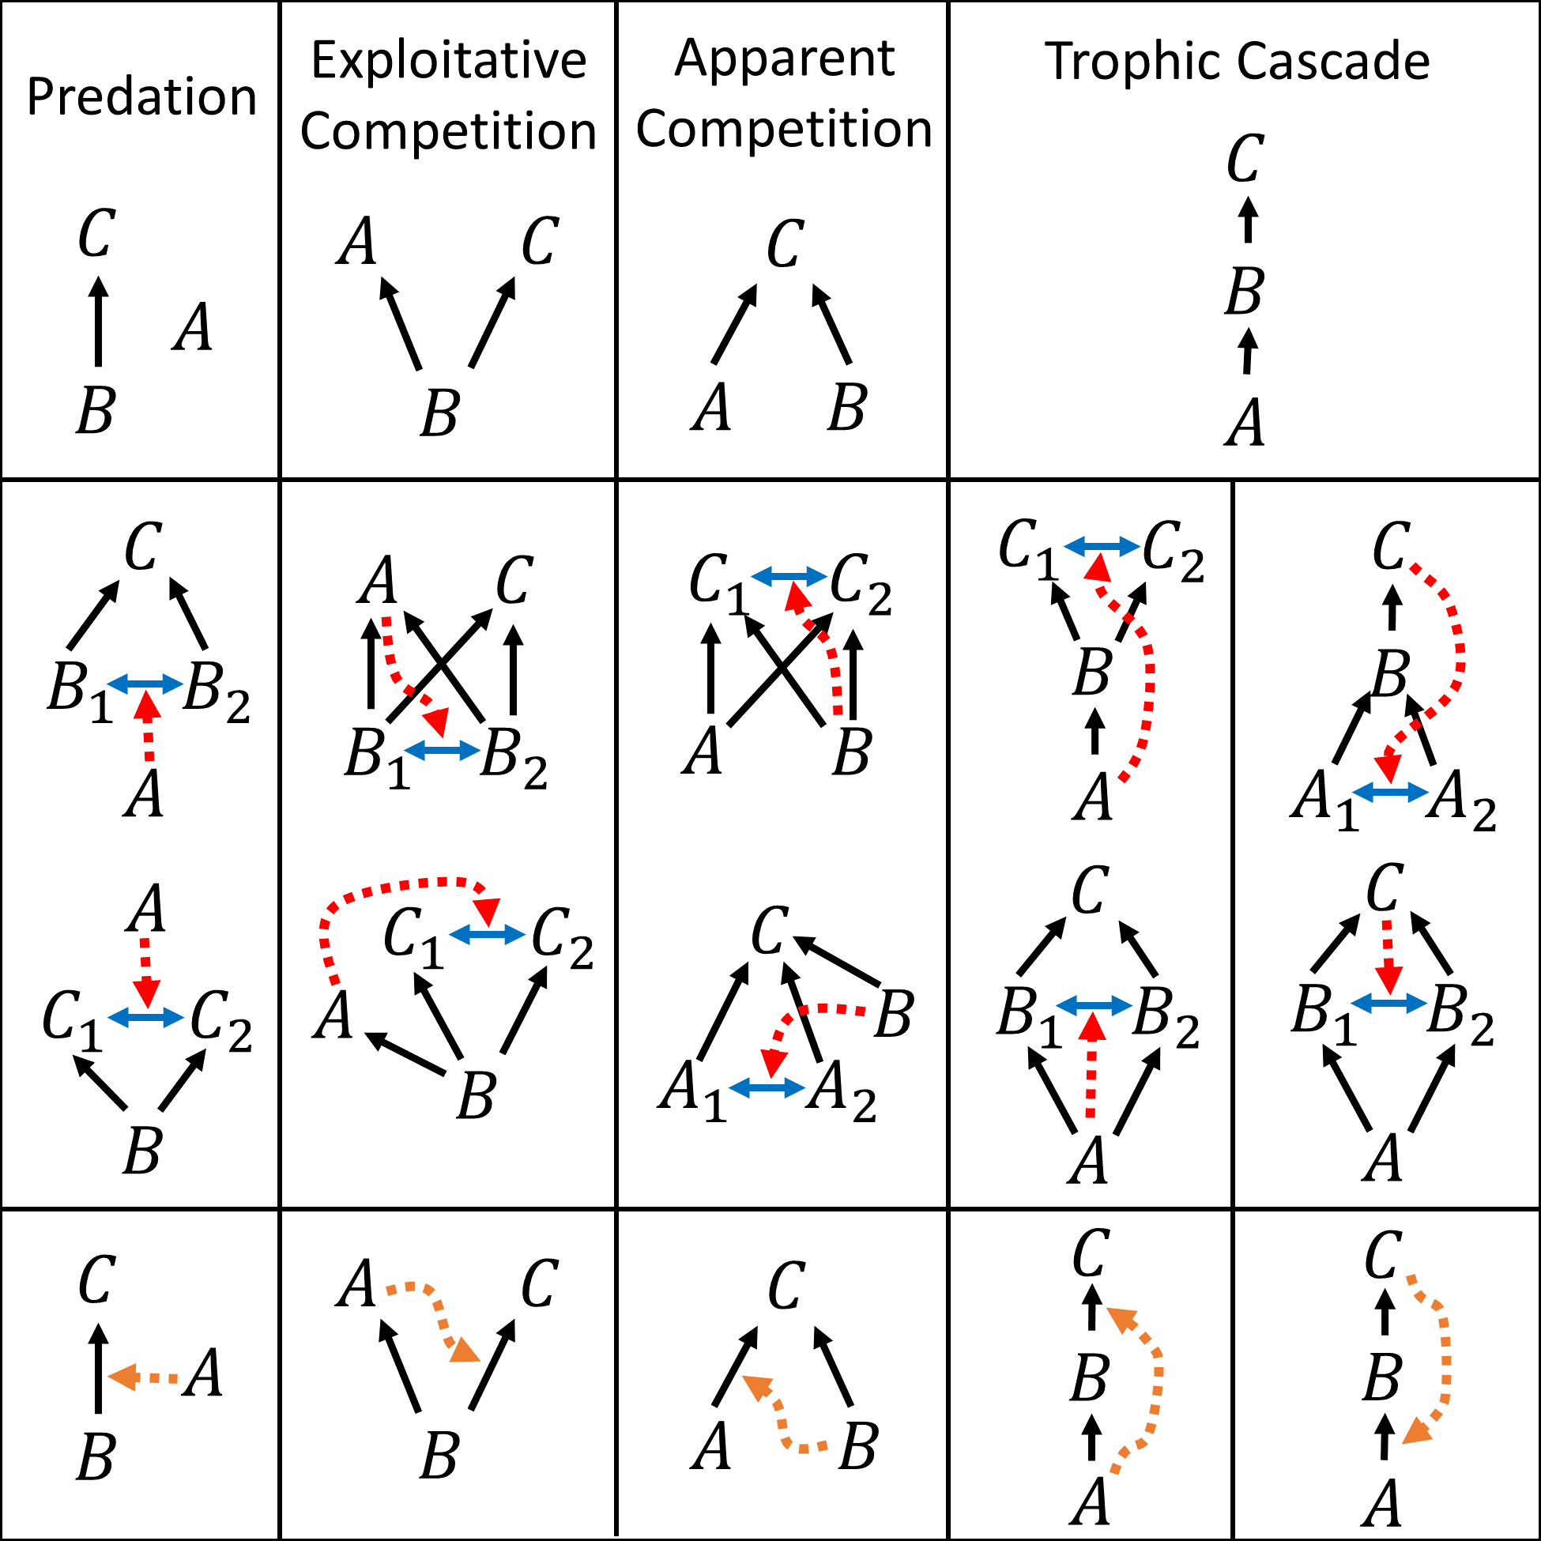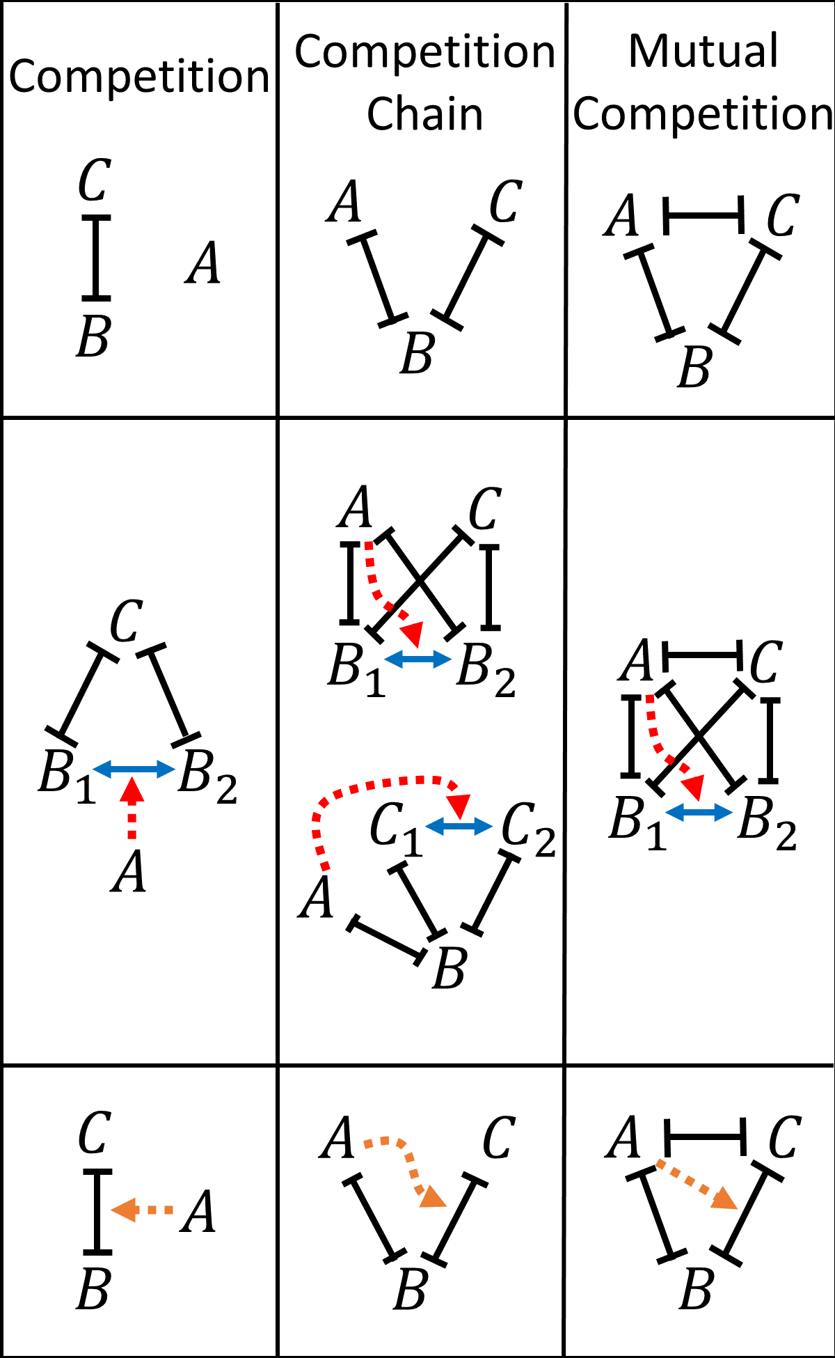

We will analyze these motifs and study how interaction modifications affect the stability of the ecosystem. Our simplification of the trait variation to two subpopulations allows us to model these motifs using simple dynamical equations. There will be equations for four variables, including the density of two species that are assumed to be homogeneous, and the density of the two subpopulations of the heterogeneous species. It is important to note that these equations will take a different form than the 4-species Lotka-Volterra equations, because the switching term between the subpopulations are not proportional to the subpopulation itself (Fig.1B); similarly, the term that describes how the switching rate depends on another species will also be not of the Lotka-Volterra type. These differences are what allow the results to evade the rules derived previously for Lotka-Volterra systems (Zeeman 1993). Note that the switching term represents the exchange of individuals between the subpopulations, which makes them a single species as opposed to two prey species. Alternatively, we can rewrite the equations by coarse-graining the prey subpopulations, using their ratio and the total population as variables (Fig.1C). The ratio then represents the trait composition of the species that shifts dynamically. We will solve these equations numerically to examine how the equilibrium depends on the parameters, as illustrated in preliminary results below.

Preliminary results:

*Microbial community experiment and modeling*. A clear example of TMIM is provided by an experiment on a microbial ecosystem (Mickalide & Kuehn, 2019). They studied three unicellular species: algae (A), bacteria (B), and ciliates (C). These species could coexist in all pairwise combinations; surprisingly, when put all together, B could not survive. It was found that B could switch from a planktonic lifestyle to aggregation, and the aggregates were protected from predation by C. When A was present, however, it promoted the transition of B from the aggregated to platonic form, which became vulnerable to C and thus unable to survive. Therefore, the extinction of B was a consequence of A influencing the trait distribution of B and its overall interaction with C. This scenario is illustrated in Fig.1B and corresponds to a special case of the first motif in Fig.2 (Motif 1a). We have modeled this example (Fig.1C) and found that, in agreement with the experiment, the presence of A would lead to the extinction of B (Fig.1D). Importantly, if the trait shift of B due to A is not taken into account, the species in this ecosystem would be thought to coexist. Thus, the appearance of the extinction region in Fig.1D is a direct consequence of TMIM and demonstrates the importance of modeling such effects for predicting the outcome of ecological dynamics.

*Theoretical results on “exploitative competition” with heterogeneous prey*. In a recent work (Jackson & Xue 2022), we considered trait heterogeneity within a prey species shared by two predators, which corresponds to Motif 2a in Fig.2. Without heterogeneity, it was expected that the competition between the predators would lead to the extinction of one of them. We showed that, if the prey population had trait variations and the predators had different preference for the trait, then a new equilibrium would emerge where all three species coexist. This could describe situations where, for example, the prey species could switch between different types of behavior that defended them against one type of predator or the other. Besides the unexpected coexistence of predators, we also observed surprising results from the model, such as the facilitation of one predator by the other (i.e., one predator is better off when the competitor is present), or the promotion of the prey by a predator (i.e., the prey is more abundant in the presence of a second predator). In more recent work (unpublished), we found that such emergent promotion can happen even with only one predator, such as in the “healthy herd” model (Packer et al. 2003). These counterintuitive effects were made possible because of TMIM: one predator influences the prey composition and hence the overall interaction strength between the prey and the other predator. We expect to see similar *abnormal* effects in other motifs that we will study.

Expected results and alternative strategies:

By analyzing the dynamical systems corresponding to different motifs (as in Fig.2), we expect to find new equilibria that are made possible by TMIM. By doing this systematically, we will be able to classify the new equilibria and compare to the restricted rules derived in previous work without considering TMIM. A concrete example is the 3-species mutual competition pattern (Fig.2 last column). When interaction modification is added to this pattern, the new Motif 7 is expected to result in equilibria that are not possible according to the classic result of (Zeeman 1993). Indeed, in the microbial community experiment of (Friedman et al. 2017), among all observed types of outcomes, there was one that did not match any of Zeeman’s diagrams (Fig.1 dashed box). This anomaly was attributed to higher-order interactions, which could arise from TMIM. Our modeling of this motif should confirm this hypothesis.

More generally, we will catalog such “abnormal” outcomes that emerge as a result of TMIM, which will provide a roadmap for future experiments looking for evidence of interaction modifications. Besides new equilibria, we also expect to see relations between species abundances that are reversed. As already seen in our preliminary results, TMIM can lead to emergent promotion of the prey population by a predator, which is opposite of the negative relation between predators and prey that is often considered. We expect similar relations to be found in other motifs. For example, in apparent competition (Fig.2 third column), the two preys are usually thought to inhibit each other because, when one increases, it tends to support more predators that will then negatively impact the other prey. However, if the latter is in fact promoted by the predator due to TMIM, then the two prey will have a positive relation instead. Similarly, in trophic cascade (Fig.2 fourth and fifth columns), it is often thought that the top predator will positively impact the bottom producer by inhibiting the middle consumer. But if the predator turns out to promote the middle consumer because of TMIM, then the sign of the cascading impact will be reversed, contrary to the common wisdom. Such “wrong signs” have been observed in ecosystems and are often attributed to omnivorous predators (refs), yet our modeling of TMIM can provide an alternative explanation. We will look for empirical evidence for the TMIM mechanism in **Aim 2** below.

The dynamical systems that we focus on here use only two subpopulations to represent the intraspecific trait variation within a population. This is a simplification for the convenience of mathematical analysis, which can be relaxed by considering more compartments in the population. We will study a few cases with multiple subpopulations to see if the two-subpopulation simplification misses important qualitative outcomes. In the limit of many subpopulations, the trait value can be treated as a continuous variable (infinitely many compartments), described by a continuous distribution within the population. Some previous work has modeled such cases by approximating the distribution as a Gaussian and tracking the mean and variance (Schreiber 2011). This approach is particularly suited for considering trait differences due to heritable genetic variation. The shift of trait distribution in this case can be a result of eco-evolutionary feedback… [Bob fill in?]

**Aim 2: Synthesizing empirical evidence for trait-mediated interaction modifications.**

Trait-mediated indirect effects have been observed in many examples (Ohgushi et al., 2012), and the resulting higher-order interactions are found to be common in ecosystems (Mayfield & Stouffer, 2017). However, there has not been a comprehensive survey of empirical studies to identify different patterns of such trait-mediated effects. Our theoretical framework will provide a scheme for classifying those trait-mediated effects. As an application of our framework, we will survey and synthesize empirical studies according to the TMIM motifs established in **Aim 1**. Our goal is to evaluate the evidence for those motifs and demonstrate the practical relevance of our framework.

Approach:

We will perform a comprehensive literature survey of known examples of TMIM and categorize them according to the motifs (Fig.2). Previous work has analyzed the prevalence of network motifs of regulatory interactions in complex networks (Milo et al., 2002), such as gene regulation patterns. Our work will apply similar analysis to ecological interactions, and will consider interaction modification patterns that have not been analyzed in this way. As part of the analysis, we will quantify the level of evidence for each motif. Such measures have been proposed for evaluating examples of bet-hedging (Simons, 2011, Grimbergen et al., 2015), where different levels of evidence are defined according to whether the intraspecific trait variation has been observed, quantified, fit to model, or tested in lab, etc. After collecting the examples of TMIM, we will advise a similar measure of strength of evidence and assess the examples accordingly.

To perform the survey, we will follow recommendations on conducting transparent and comprehensive reviews outlined in the PRISMA framework (Page et al. 2021). We will utilize a semi-automated workflow (modified from Pham et al. 2021) by developing a suitable dictionary of terms that can be used to discriminate among the motifs shown in Figure x. This will require integration of the theoretical criteria described above with criteria for describing experimental and observational studies, as defined by previous work on higher-order and trait-mediated interactions in ecology (refs). This dictionary will be ‘seeded’ by key terms such as ‘higher order interaction’, ‘interaction modification’ etc. based on the expertise of Co-PIs RDH and MAL, and will be enhanced by consultation with other scientists who study such interactions. We will use text-mining methods based on these key terms together with criteria for quality control (scope of peer-reviewed journals, ranges of dates, etc.) to quantify the scope of evidence for our study (we anticipate this to result in a large number of studies) using text-mining software such as DistillerSR (Gartelehner et al. 2019) and ASReview (vand de Schoot et al. 2021). To evaluate the adequacy of the dictionary and text-mining methods, we will select a smaller random subset of studies to evaluate by hand. If we are not satisfied with the automated methods, we will work to refine our dictionaries and other selection criteria in an iterative way until we find that there is adequate agreement between our hand-curated data and the algorithm. We will then tabulate and categorize these studies according to criteria that allow a meta-analysis around selected questions.

Although we anticipate that our questions will evolve somewhat as we get through **Aim 1** above, at this point we anticipate focusing on the following questions:

* Are some motifs more prevalent than others?
* Are there possible biases in documenting/quantifying different motifs?
* Are motifs differentially prevalent in different types of ecosystems or organisms? Of particular interest is whether they differ between microbial and ‘macrobial’ communities.
* Are different motifs differentially associated with different aspects of ecology (e.g. behavior, life-history traits, plasticity vs genetics)?
* Are there apparent knowledge gaps that can improve future studies?

To evaluate the levels of evidence for TMIM found in the above studies, we will make a rubric based on how much details are known about the trait variations that caused significant effects on the ecosystem. We anticipate focusing on the following aspects:

* Are the traits that cause interaction modification known in the ecosystem?
* Are the trait shifts qualitatively observed or quantitatively measured?
* Are the mechanisms of trait interference by another species known?
* Are the outcomes (e.g., coexistence or extinction) possible without interaction modification?

We will assign the potential examples of TMIM to different levels of evidence using the rubric. As a meta-analysis, we will then combine the statistics of these evidence levels to assess the overall status of research on TMIM.

Preliminary results:

Here we mention several examples in the literature that are known to us, which all belong to some of the motifs constructed in Fig.2. We focus on examples where not only higher-order interactions are implied, but also the mechanisms of interaction modification in terms of the traits involved are known.

|  |  |  |  |  |
| --- | --- | --- | --- | --- |
| Motif | Ecosystem | Known as | Trait being modified | References |
| 1a | Algae, Bacteria, Ciliates | “ABC” system | Algae induce bacteria to switch from aggregated to platonic cell type. | (Mickalide & Kuehn, 2019) |
| 4d | Plants, grasshoppers, spiders |  | Spiders induce grasshoppers to switch from exposed foraging behavior to hiding. | (Schmitz et al. 1997) |
| 1a? |  | “emergent facilitation” | Predator induces shift in the juvenile/adult distribution of the prey. | (de Roos et al. 2008) and references therein |
| 1a (2a) |  | “healthy-herd effect” | Pathogen (can be micropredator) results in an infected subpopulation of the prey. | (Duffy) and references therein |
| 2a | hellgrammites,  greenside darters, creek chubs, mayfly | “multiple predator effect” | Unknown | (Vance-Chalcraft & Soluk, 2005) |
| 3a |  |  |  | (Schreiber et al. 2011) |

Expected results and alternative strategies:

We expect to complete a thorough survey of ecological examples of TMIM. Our categorization of these examples according to the motifs and the assessment of their evidence levels will provide a big picture for the prevalence and significance of interaction modification in ecosystems. This will corroborate our theoretical results in Aim 1. In particular, given the examples found for each motif, we will see what types of equilibria are observed and whether they contradict the mathematical rules derived from models without interaction modification. Our results will guide future empirical work by suggesting criteria by which studies on an example ecosystem must meet to constitute strong evidence for TMIM. If such examples are found, we will be able to model them according to their motifs (as in **Aim 1**) and predict the parameter ranges that allow new behavior to emerge, which can be tested in future experiments. If we do not find clear, quantitative examples, we will suggest promising candidates and experimental designs that could reveal significant consequences of TMIM.

**Aim 3: Studying trait-structured ecological community models.**

~~The new motifs involving trait-mediated interaction modifications among several species can affect the stability of large ecological networks.~~ As illustrated by the ABC experiment mentioned in **Aim 1**, interaction modifications can lead to unanticipated extinction of species by altering the local assembly of communities. While this can be studied by the detailed study of motifs involving small numbers of species, how this may play out in highly diverse (and thus more realistic) sets of species is unknown because the outcome of such disturbances on large scales requires accounting for the potential effect of intraspecific trait variations and interaction modifications in large networks. In this Aim, we will study the consequences of such effects at the network level using mathematical models. Our goal is to obtain conditions under which TMIM generally enhances or weakens the stability of large ecological networks. For this purpose, we will develop a framework of “trait-structured” population models that can incorporate intraspecific trait variation as well as interference by other species.

Approach:

Because it is difficult to measure interaction strengths among all species, let alone the modification of the interaction strengths, we study large ecological networks using a statistical approach (Wilson et al., 2003, Rossberg, 2013). A focus on macroscopic properties of the network (e.g. feasibility, stability) may be robust to many of the details of the interactions, they can often be predicted using on the statistical properties of the interaction strengths and the general structure of the network (Barbier et al., 2018). This leads to a “disordered systems” approach, which considers the interaction strengths between species as being randomly drawn from a statistical distribution to gain general insights that extend beyond the particular details.

In ecology, May (1972) used such an approach to predict the stability of a community of interacting species by using random Lotka-Volterra models to predict the distribution of eigenvalues that characterized the dynamics of a set of interacting species as a function of the number of species (S), the proportion of non-zero off-diagonal elements (C) and the average standardized pairwise per-capita interaction coefficients (A). This showed that stability (the real part of the dominant eigenvalue) was generally constrained by the inequality SCA2<1.

Using random Lotka-Volterra models has since become one of the primary ways to study the dynamics of highly diverse local communities (e.g. Rossberg 2013). An intriguing approach is to extend the approach to apply to different possible elaborations from May’s simple example. For example, Benaim and Lobry (2016) modified May’s approach to study how fluctuating environments in models with two patches could modify coexistence of species. Gravel et al. (2016) expanded on this by deriving a multi-scale version of May’s result (Figure 6). They combined local communities subject to May’s constraints with dispersal by the component species among these local communities. Assuming that there was environmental variation among local communities, they derived a modification of May’s result at high dispersal rates as being SCA2/Ne<1, where Ne describes the effective number of ‘ecologically distinct’ environments (where there are no correlations among local A matrices. At low dispersal, May’s result was altered to be SCA2<1-d, where d is the dispersal rate.

This focus on stability (leading eigenvalue) as the macroscopic feature of interest has recently been expanded to also address other features such as resulting species richness (allowing for extinctions), total population size (or biomass), the abundance distribution of component species, the temporal variability of populations to demographic noise, and the average turnover of individuals (or biomass) in the community (Bunin, 2017) using ‘cavity modeling’ methods. Barbier et al. (2018) argued that this can serve as a baseline template that can be used to examine how ‘partially structure’ models, in which selected patterns of correlations among predictors can be hypothesized, alter results.

~~The classic result of (May, 1972) put a constraint on the variance of interaction strengths in order for the system to be stable. More recent work has studied the persistence of species and its dependence on the network structure (Barbier et al., 2018), as well as community assembly from a large species pool (Servan et al., 2018). This disordered systems approach, while missing details about specific ecosystems, provides a “null prediction” for general ecological networks (Barbier et al., 2018) — The actual properties of an ecosystem will deviate from the null predictions if there are important aspects of the ecosystem beyond the statistical distribution of interaction strengths, such as the network structure of trophic levels or the nature of interactions (e.g., trophic vs. competitive).~~

The disordered systems approach at present assumes that Interactions between species are pairwise and fixed, thus leaving out the possibility of interaction modifications and the resulting higher-order interactions. We will generalize this approach by incorporating such missing effects using ‘partially structured’ approaches and see how they change the general predictions on ecosystem stability and species coexistence. To do so, we will model TMIM by considering the trait distribution within a species that can change dynamically and can be influenced by other species, which means we have to model the inner structure of each population to account for trait variations. For simplicity, as done in **Aim 1**, we will consider subpopulations with different trait values that affect their interaction strengths with other species. We will call such models “trait-structured”, as opposed to spatially structured models of meta-communities (refs).

~~In a recent work by Co-PI MAL, the disordered systems approach was extended to studying the stability of meta-communities (Gravel et al., 2016). It was shown that, when the spatial structure of a meta-community is taken into account, the previously derived constraint on ecosystem stability (May, 1972) is relaxed depending on the number of local communities. Mathematically, adding spatial structure to the ecosystem amounts to introducing more dynamical variables: The interaction matrix is enlarged according to the number of local communities (Figure 6A), where the diagonal blocks are the original interaction strengths and the off-diagonal blocks represent dispersal between communities, the values of which are drawn randomly. It was found that more degrees of freedom tend to stabilize the ecosystem.~~

By analogy with the approach of Gravel et al. (2016), we can model trait variation within a species by introducing internal degrees of freedom to the species. For example, one species would split into multiple subpopulations, thus introducing new variables and enlarging the interaction matrix (Figure 6B). Specifically, one element of the original interaction matrix will be split into a small matrix, representing potentially different interaction strengths of the subpopulations (Figure 6B). The diagonal blocks of the enlarged matrix represent the intraspecific interaction between the subpopulations of the same species, whereas the off-diagonal blocks represent the interspecific interactions between subpopulations of different species. Following the disordered systems approach, the strengths of intra- and inter-specific interactions will be chosen from statistical distributions that characterize the extent of trait variation in the ecosystem. The stability of the ecosystem can then be studied similarly to (May, 1972) and (Gravel et al., 2016). By analogy to the previous result on spatial structure, we expect to be able to show that intraspecific trait structure would also generally help stabilize ecosystems.

Figure 6: Extending the disordered systems approach of studying large ecological networks by incorporating extra degrees of freedom. (A) Introducing the spatial structure of meta-communities (adapted from Gravel et al., 2016): The original interaction matrix forms the diagonal blocks (blue) of the enlarged matrix , and the off-diagonal blocks (orange) represent dispersal rates between the local communities. The spatial degrees of freedom tend to stabilize the ecosystem. (B) Introducing intraspecific variation within the species: Each element of the original interaction matrix splits into a small matrix, forming an enlarged matrix . The diagonal blocks (blue) represent the intraspecific interaction among the subpopulations of the same species, and the off-diagonal blocks (orange) represent the interspecific interactions between the subpopulations of different species.

However, we may also be able to identify if this can depend on the statistical properties of the trait variation. To study the effect of interaction modification due to the influence on trait distribution by other species, we will incorporate the network motifs studied in **Aim 1** into the disordered systems approach. This can be done by introducing appropriate terms in the dynamical system, as illustrated in Fig.1B. Note that such terms are not of the Lotka-Volterra type, as they are not proportional to the variable on the left-hand side. Therefore, we will have to extend the disordered systems approach by including terms of this form, but will follow the same approach of randomly drawing the strengths of such terms. Despite the expected trend that intraspecific trait variations will stabilize ecosystems, the new terms can destabilize the ecosystem, as in the ABC example (**Aim 1** preliminary results). Which effect prevails may depend on the statistical properties of the new parameters introduced into the model (Bairey et al., 2016). Thus, we will study how the species-level properties, such as the extent of trait variation and interaction modification, affect the community-level properties such as ecosystem stability.

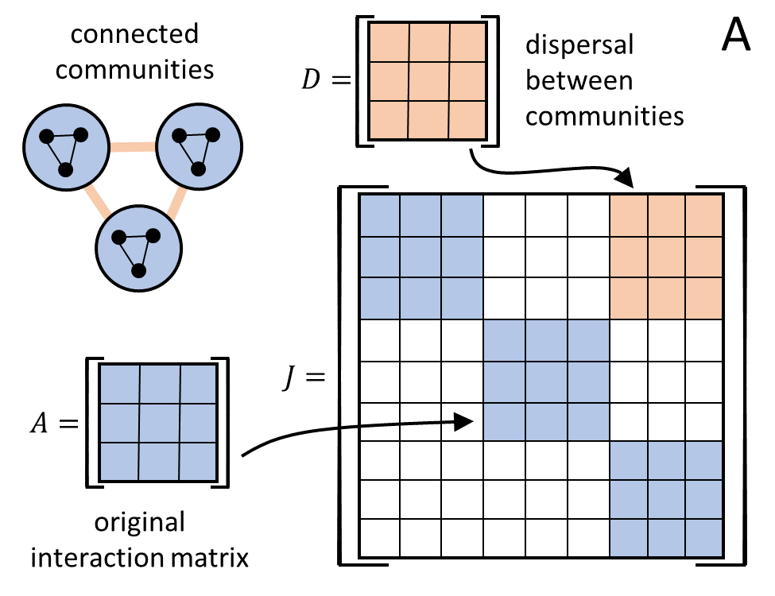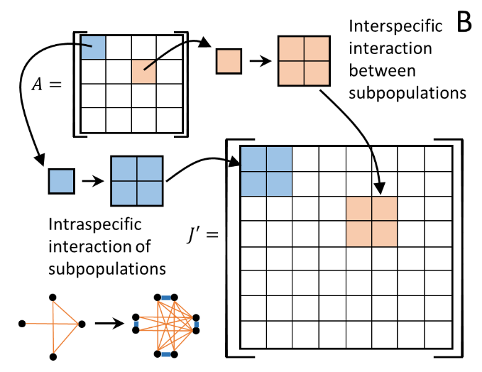

Expected results and alternative strategies:

The disordered systems approach has roots in both theoretical ecology and statistical physics. This approach allows us to test the importance of TMIM statistically and to scale up the predictions from a few species to a large network. In connection with the work in **Aim 1 & 2**, we will estimate how much effect each motif has on a large ecosystem, which will give a measure of statistical importance of the motifs. This may be compared to the amount of empirical evidence for the motifs. We hypothesize that the motifs that have a stronger effect on stabilizing the ecosystem may be more commonly observed in nature.

Higher-order interactions among multiple species have been modeled using similar statistical approaches, and have been shown to stabilize ecosystems and promote biodiversity (Bairey et al. 2016, Mayfield & Stouffer 2017, Grilli et al. 2017, Letten & Stouffer 2019, Kleinhesselink et al. 2022). Our approach here provides more mechanistic details on how such higher-order interactions may arise from different TMIM motifs. Given those previous results that indicated significant stabilizing effect of higher-order interactions, we are confident that our approach will also produce positive results.

Building on these expected results, we anticipate further, more challenging questions. For example, if HOI is implied in a real or simulated ecosystem, would it be possible to infer the TMIM motif that could give rise to such HOI? We will try to address this problem by comparing the typical forms and strengths of HOIs that result from different motifs, as well as the generic structure of equilibrium states. We expect to use these statistical properties of ecological networks to constrain the types of underlying motifs. If this turns out to be impossible, then it will reveal the limitation of the disordered systems approach.

[any final remarks?]

**BROADER IMPACTS**

Ecosystem stability and species persistence are perfect subjects for raising the public awareness of environmental changes and ecological challenges. We plan to use topics related to our research to engage educators and students, to develop new teaching strategies, and to involve underrepresented groups in STEM education. Our main approach will be to collaborate with the *Scientist in Every Florida School* (SEFS) program hosted by the Thompson Earth Systems Institute (TESI) in the Florida Museum of Natural History at UF. SEFS has a mission to “engage Florida K-12 students and teachers in cutting-edge research by providing science role models and experiences that inspire the future stewards of our planet”, with a focus on **Title I schools** and a potential to impact nearly **2.3 million K-12 students and thousands of teachers** statewide. The PI has collaborated with SEFS on multiple occasions, including teachers’ professional development programs and classroom visits to underrepresented student groups. For the proposed project, we have reached out to SEFS and agreed to collaborate on educating teachers and students about ecological concepts through an experimental kit developed by our research team.

Experimental kit design: Our goal is to educate students about ecological concepts such as intraspecific and interspecific competition, species coexistence, and invasive species. To make these general concepts more concrete, we will create an educational kit to conduct simple but informative competition experiments with duckweeds (and ecologically related ferns, *Salvinia* and *Azolla*) that harness the contributions of the students to conduct highly replicated experiments. The samples we provide include native species to Florida, such as *Lemna aequinoctialis*, and already established exotic species, such as *Salvinia minima*. These plants are easy to grow at home or in classrooms. The basic idea is to measure the strengths of intra- and inter-specific interactions by growing them in small containers provided in the kit. The kit includes species samples, multiple disposable cups to be used as microcosms, some potting soil to provide nutrients in the water, a ruler and a measuring spoon. Cell phone cameras can be used to take images for data collection (students without smart phones can ask teachers for help).

The experiment will proceed as follows: First, the sample species are arranged into several treatments, each with different combinations of initial plant densities. Images are taken to allow measurement of leaf area at the beginning of the experiment. Then the plants are grown in water cups for three weeks, during which minimal care is required to ensure lighting, water levels, and no destruction by uncontrolled events. At the end of the experiment, images are taken again for comparison with initial data. Finally, the images can be analyzed using a custom program written in R-markdown that will be provided to users through download. The program quantifies reciprocal invasion abilities (critical for determining if coexistence is possible) and overyielding (a distinct way to study the strength of competition). One advantage of the experiment is that results from different people can be treated as replicates and pooled together for analysis. This experimental design has been successfully tested in a remote course taught by co-PI MAL and typical results are shown in Figure xx. We expect that the teachers and their students will get similar results (which might vary depending on the actual species identities used in an experiment).

Further, we will organize the overall program to work as a ‘distributed experiment’ in which the results from different classes can be organized into a larger, and more comprehensive, study that could lead to a publication in the primary literature. To do this, we will use a dedicated website that allows participants to upload results to a database and participate in a coordinated research network. The database will be monitored and analyzed by the postdoc supported by this grant.

Educator development: To demonstrate and promote the use of the experimental kit, we will work with the SEFS program to organize a 1-day workshop for teachers’ professional development. We will recruit 10 teachers from Florida high schools and will train them on how to use the experimental kit as well as scaffold the scientific background. Multiple kits will be distributed to the teachers for use in their classes, engaging students in collaborative groups to do the experiment. A SEFS Education Outreach Coordinator will provide support recruiting the teachers and planning the workshop at TESI. The PIs and their students and postdocs will be responsible for making presentations, doing demonstrations, answering questions, and giving the teachers a tour of the labs and field sites at UF.

Figure xx: [need bigger labels] Previous results of competition experiment between *Lemna* and *Salvinia* using our proposed methods. There are three treatments that differ in the relative amounts of each species, while holding total amount constant. The left panel shows a negative relationship between relative growth and relative abundance, i.e., each species can increase relative to the other species when they are rare, consistent with the idea that they can stably coexist. The right panel shows that total yield is higher when the two species are initially equally abundant, indicating that the even mixture is more ecologically efficient than when either species is overly abundant, also consistent with stable coexistence. This experiment was repeated in three other classes with qualitatively similar results.

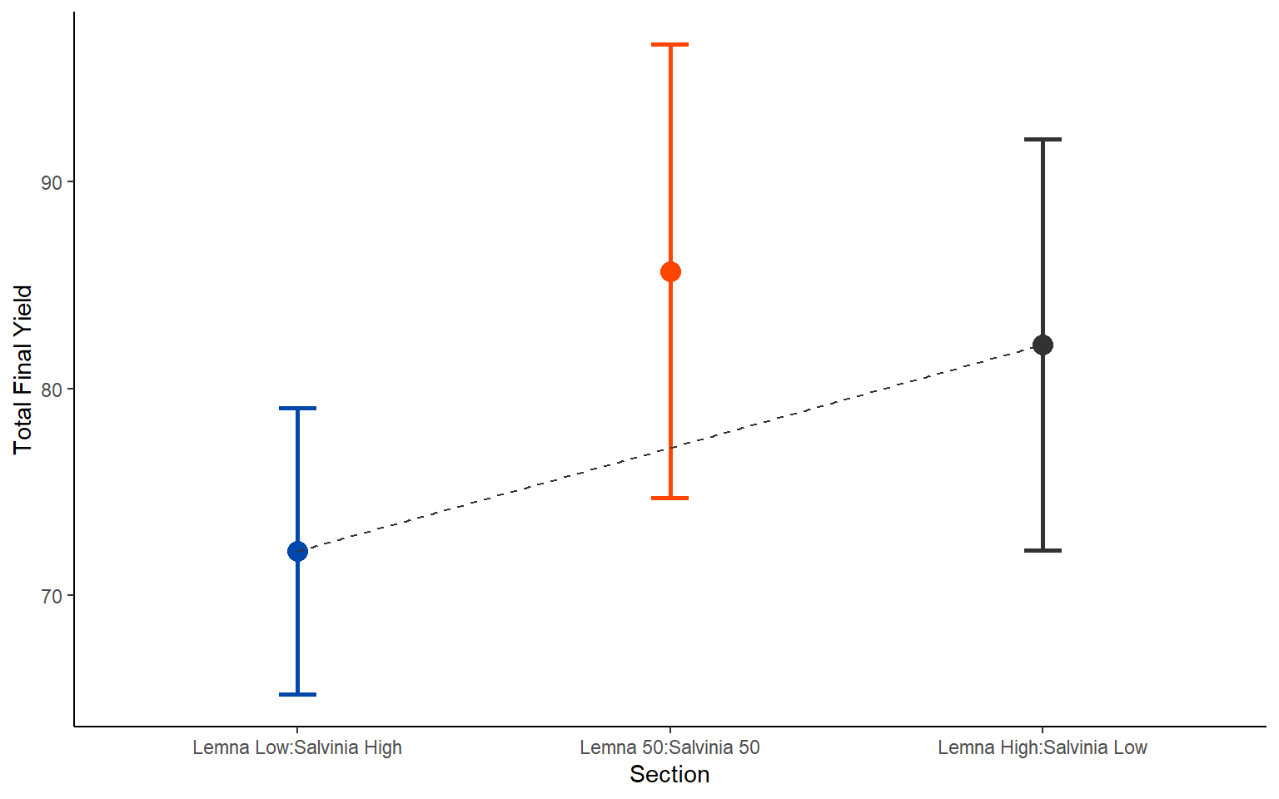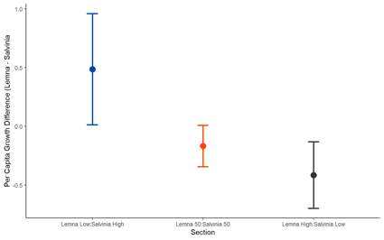

The schedule for the 1-day workshop would go as follows: There will be a welcome session by the SEFS program with information about opportunities for training and engaging underrepresented groups. The scientific program will start with a lecture on the ecological concepts and motivations for the experiment. Then we will do a demo, involving the teacher participants, on how to set up the experiment, including handling the species samples and assembling the microcosms for different treatments, which will take about 1-2 hours. After a lunch break, we will go over data collection and analyses, including processing cellphone images and analyzing example data with the provided software. Participants will also have a tour of the PIs’ labs and interact with the lab members. Lunch and transportation are provided by TESI.

In the following months, we will keep in contact with the teachers to check on the progress of the experiment. SEFS will help coordinate the communications and direct questions to the PIs. We plan for one visit to each teacher’s classroom (in-person or by Zoom, either by the PIs or lab members) to interact with their students, explain the experimental results, and collect feedback for future improvements.

Expected outcome: Our experimental kit will be used to improve STEM education by providing first-hand research-oriented study experience for students, which will boost an interdisciplinary interaction between biology and mathematics. This experiment illustrates important concepts related to the **Florida CPALMS learning standards** SC.912.L.15.3 and SC.912.L.17.8 on biodiversity: The species competition experiment teaches students “*how [biodiversity] is decreased by the natural process of extinction*”, and the use of both native and exotic species in the experiment teaches students to “*recognize the consequences of the losses of biodiversity due to […] the introduction of invasive, non-native species*”. In addition, the experiment will teach students the basic process of conducting scientific experiments, the careful collection of data, and the quantitative ways of analyzing data to draw conclusions from facts and evidence. Through the large SEFS network, we will be able to reach underserved school areas and underrepresented student groups within Florida. This strategy will promote broader participation in STEM education and contribute to diversity, equity, and inclusion in academic studies.

Assessment plan: The success of our outreach program will be assessed with the help of SEFS. They have regularly organized teachers’ workshops and classroom visits. The Education Outreach Coordinator will work with us to ensure the success of the workshop and provide training on communication if necessary. After the workshop, the Coordinator will follow up with the teachers regularly to offer help and receive feedback, and will provide an evaluation of the program to the PIs for future consideration.

**RESULTS FROM PRIOR NSF SUPPORT**

R D Holt: IOS 1354754, subaward FY 2016-019-M1, 2014-2019, $149,022, “SG: Evolutionary lag and the effects of clonal structure”. **Intellectual Merit**: The overall goal of this project is to determine how clonal structure impacts the rate of evolution. We showed that the effects of clonality on evolutionary lag and rescue critically depend on whether the environmental change is an abrupt or continuous transition, and on the matching between clonal offspring and their parents. Products include: 8 published papers, 4 coauthored by RDH, 6 invited seminars at academic institutions and presentations at international meetings. **Broader Impacts**: This project has led to the training of students at both the University of Florida (one PhD student) and the University of Kansas (two undergraduates, one an underrepresented minority). The results have been woven into lectures in undergraduate and graduate classes.

M A Leibold: EF 2025118, 2020-2025, $500,148, “Collaborative Research: MTM2: Searching for General Rules Governing Microbiome Dynamics”. **Intellectual Merit**: This recently initiated project seeks to study microbial dynamics. MAL’s part of the proposal is focused on linking process models to the analysis of distributions using JSDM (joint species distribution models) and related approaches. We will conduct a meta-analysis of microbial systems and theory to clarify the interpretation of the outputs they produce. We find that current interpretations of JSDMs are unwarranted in relation to process dynamics except under exceptional and unrealistic assumptions, but that the statistical description of the results are more robust to such assumptions. We have one submitted paper and two manuscripts in preparation that describe these issues. **Broader Impacts**: Two students (one from under-represented group) are currently supported on this grant. We are also developing a curriculum around the theme of “Rules of Life – Microbiomes” and workshops on cross-disciplinary synthesis at various meetings as well as involvement in STEM K-12 education. **Relevance to proposed study**: The current proposal is using a process based model that we have identified as likely to be useful in the analysis of JSDMs, and our experimental work should be able to clarify the degree to which this is true.

**REFERENCES CITED**

Agrawal, A. A. (2001). Phenotypic plasticity in the interactions and evolution of species. *Science*, *294*(5541), 321–326. https://doi.org/10.1126/science.1060701

Anderegg, L. D. L., Berner, L. T., Badgley, G., Sethi, M. L., Law, B. E., & HilleRisLambers, J. (2018). Within-species patterns challenge our understanding of the leaf economics spectrum. *Ecology Letters*, *21*(5), 734–744. https://doi.org/https://doi.org/10.1111/ele.12945

Armitage, D. W., & Jones, S. E. (2019). Negative frequency‐dependent growth underlies the stable coexistence of two cosmopolitan aquatic plants. *Ecology*, *100*(5), e02657. https://doi.org/10.1002/ecy.2657

Bairey, E., Kelsic, E. D., & Kishony, R. (2016). High-order species interactions shape ecosystem diversity. *Nature Communications*, *7*. https://doi.org/10.1038/ncomms12285

Barabás, G., & D’Andrea, R. (2016). The effect of intraspecific variation and heritability on community pattern and robustness. *Ecology Letters*, *19*(8), 977–986. https://doi.org/https://doi.org/10.1111/ele.12636

Barbier, M., Arnoldi, J. F., Bunin, G., & Loreau, M. (2018). Generic assembly patterns in complex ecological communities. *Proceedings of the National Academy of Sciences*, *115*(9), 2156–2161. https://doi.org/10.1073/pnas.1710352115

Berg, M. P., & Ellers, J. (2010). Trait plasticity in species interactions: a driving force of community dynamics. *Evolutionary Ecology*, *24*(3), 617–629. https://doi.org/10.1007/s10682-009-9347-8

Bolnick, D. I., Amarasekare, P., Araújo, M. S., Bürger, R., Levine, J. M., Novak, M., Rudolf, V. H. W., Schreiber, S. J., Urban, M. C., & Vasseur, D. A. (2011). Why intraspecific trait variation matters in community ecology. *Trends in Ecology & Evolution*, *26*(4), 183–192. https://doi.org/https://doi.org/10.1016/j.tree.2011.01.009

Callaway, R. M., Pennings, S. C., & Richards, C. L. (2003). Phenotypic plasticity and interactions among plants. *Ecology,* 84(5), 1115–1128. https://doi.org/10.1890/0012-9658(2003)084[1115:PPAIAP]2.0.CO;2

Chase, J. M., & Leibold, M. A. (2003). *Ecological Niches: Linking Classical and Contemporary Approaches*. University of Chicago Press. https://books.google.com/books?id=Ssmcl_ubQUQC

Chen, X., Sun, J., Wang, M., Lyu, M., Niklas, K. J., Michaletz, S. T., Zhong, Q., & Cheng, D. (2020). The leaf economics spectrum constrains phenotypic plasticity across a light gradient. *Frontiers in Plant Science,* 11, 735. https://www.frontiersin.org/article/10.3389/fpls.2020.00735

Clatworthy, J. N., & Harper, J. L. (1962). The comparative biology of closely related species living in the same area: V. Inter- and intraspecific interference within cultures of Lemna spp. and Salvinia natans. *Journal of Experimental Botany*, *13*(2), 307–324. https://doi.org/10.1093/jxb/13.2.307

Dale, M. R. T., & Fortin, M.-J. (2021). *Quantitative Analysis of Ecological Networks*. Cambrdge University Press, Cambridge, UK.

Delmas, E., Besson, M., Brice, M.-H., Burkle, L. A., Dalla Riva, G. v, Fortin, M.-J., Gravel, D., Guimarães Jr., P. R., Hembry, D. H., Newman, E. A., Olesen, J. M., Pires, M. M., Yeakel, J. D., & Poisot, T. (2019). Analysing ecological networks of species interactions. *Biological Reviews*, *94*(1), 16–36. https://doi.org/https://doi.org/10.1111/brv.12433

Dormann, C. F., Fründ, J., & Schaefer, H. M. (2017). Identifying causes of patterns in ecological networks: Opportunities and limitations. *Annual Review of Ecology, Evolution, and Systematics*, *48*(1), 559–584. https://doi.org/10.1146/annurev-ecolsys-110316-022928

Downing, A. L., Jackson, C., Plunkett, C., Ackerman Lockhart, J., Schlater, S. M., & Leibold, M. A. (2020). Temporal stability vs. community matrix measures of stability and the role of weak interactions. *Ecology Letters*, *23*(10), 1468–1478. https://doi.org/https://doi.org/10.1111/ele.13538

Friedman, J., Higgins, L. M., & Gore, J. (2017). Community structure follows simple assembly rules in microbial microcosms. *Nature Ecology & Evolution*, *1*(5), 109. https://doi.org/10.1038/s41559-017-0109

Fritschie, K. J., Cardinale, B. J., Alexandrou, M. A., & Oakley, T. H. (2014). Evolutionary history and the strength of species interactions: testing the phylogenetic limiting similarity hypothesis. *Ecology*, *95*(5), 1407–1417. https://doi.org/https://doi.org/10.1890/13-0986.1

Funk, J. L., & Cornwell, W. K. (2013). Leaf traits within communities: Context may affect the mapping of traits to function. *Ecology*, *94*(9), 1893–1897. https://doi.org/https://doi.org/10.1890/12-1602.1

García-Callejas, D., Molowny-Horas, R., & Araújo, M. B. (2018). Multiple interactions networks: Towards more realistic descriptions of the web of life. *Oikos*, *127*(1), 5–22. https://doi.org/https://doi.org/10.1111/oik.04428

Godoy, O., & Levine, J. M. (2014). Phenology effects on invasion success: insights from coupling field experiments to coexistence theory. *Ecology*, *95*(3), 726–736. https://doi.org/https://doi.org/10.1890/13-1157.1

Golubski, A. J., & Abrams, P. A. (2011). Modifying modifiers: What happens when interspecific interactions interact? *Journal of Animal Ecology*, *80*(5), 1097–1108. https://doi.org/https://doi.org/10.1111/j.1365-2656.2011.01852.x

Gravel, D., Massol, F., & Leibold, M. A. (2016). Stability and complexity in model meta-ecosystems. *Nature Communications*, *7*, 12457. https://doi.org/10.1038/ncomms12457

Grimbergen, A. J., Siebring, J., Solopova, A., & Kuipers, O. P. (2015). Microbial bet-hedging: the power of being different. *Current Opinion in Microbiology*, *25*, 67–72. https://doi.org/10.1016/j.mib.2015.04.008

Grubb, P. J. (2016). Trade-offs in interspecific comparisons in plant ecology and how plants overcome proposed constraints. *Plant Ecology & Diversity*, *9*(1), 3–33. https://doi.org/10.1080/17550874.2015.1048761

Guimarães, P. R. (2020). The structure of ecological networks across levels of organization. *Annual Review of Ecology, Evolution, and Systematics*, *51*(1), 433–460. https://doi.org/10.1146/annurev-ecolsys-012220-120819

Hart, S. P., Schreiber, S. J., & Levine, J. M. (2016). How variation between individuals affects species coexistence. *Ecology Letters*, *19*(8), 825–838. https://doi.org/https://doi.org/10.1111/ele.12618

Hausch, S., Vamosi, S. M., & Fox, J. W. (2018). Effects of intraspecific phenotypic variation on species coexistence. *Ecology*, *99*(6), 1453–1462. https://doi.org/https://doi.org/10.1002/ecy.2346

Henry, C., John, G. P., Pan, R., Bartlett, M. K., Fletcher, L. R., Scoffoni, C., & Sack, L. (2019). A stomatal safety-efficiency trade-off constrains responses to leaf dehydration. *Nature Communications*, *10*(1), 3398. https://doi.org/10.1038/s41467-019-11006-1

Holt, R. D., & Barfield, M. (2012). Trait-mediated effects, density dependence and the dynamic stability of ecological systems. In *Trait-mediated indirect interactions: ecological and evolutionary perspectives*. Cambridge University Press.

Holt, R. D., & Barfield, M. (2013). Direct plant-predator interactions as determinants of food chain dynamics. *Journal of Theoretical Biology*, *339*, 47–57. https://doi.org/https://doi.org/10.1016/j.jtbi.2013.04.034

Hunt, R., & Cornelissen, J. H. C. (1997). Components of relative growth rate and their interrelations in 59 temperate plant species. *New Phytologist*, *135*(3), 395–417. https://doi.org/10.1046/j.1469-8137.1997.00671.x

John, G. P., Henry, C., & Sack, L. (2018). Leaf rehydration capacity: Associations with other indices of drought tolerance and environment. *Plant, Cell & Environment*, *41*(11), 2638–2653. https://doi.org/https://doi.org/10.1111/pce.13390

John, G. P., Scoffoni, C., Buckley, T. N., Villar, R., Poorter, H., & Sack, L. (2017). The anatomical and compositional basis of leaf mass per area. *Ecology Letters*, *20*(4), 412–425. https://doi.org/https://doi.org/10.1111/ele.12739

Keenan, T. F., & Niinemets, Ü. (2016). Global leaf trait estimates biased due to plasticity in the shade. *Nature Plants*, *3*(1), 16201. https://doi.org/10.1038/nplants.2016.201

Kohram, M., Vashistha, H., Leibler, S., Xue, B. K., & Salman, H. (2021). Bacterial Growth Control Mechanisms Inferred from Multivariate Statistical Analysis of Single-Cell Measurements. *Current Biology*, *31*(5), 955-964.e4. https://doi.org/10.1016/j.cub.2020.11.063

Kufel, L., Strzałek, M., & Przetakiewicz, A. (2018). Plant response to overcrowding – Lemna minor example. *Acta Oecologica*, *91*, 73–80. https://doi.org/https://doi.org/10.1016/j.actao.2018.06.007

Law, R., & Morton, R. D. (1996). Permanence and the assembly of ecological communities. *Ecology*, *77*(3), 762–775. https://doi.org/https://doi.org/10.2307/2265500

Leibold, M. A., Hall, S. R., Smith, V. H., & Lytle, D. A. (2017). Herbivory enhances the diversity of primary producers in pond ecosystems. *Ecology*, *98*(1), 48–56. https://doi.org/https://doi.org/10.1002/ecy.1636

Levine, J. M., Bascompte, J., Adler, P. B., & Allesina, S. (2017). Beyond pairwise mechanisms of species coexistence in complex communities. *Nature*, *546*(7656), 56–64. https://doi.org/10.1038/nature22898

Li, J., Zhou, Q., & Campos, L. C. (2017). Removal of selected emerging PPCP compounds using greater duckweed (Spirodela polyrhiza) based lab-scale free water constructed wetland. *Water Research*, *126*, 252–261. https://doi.org/https://doi.org/10.1016/j.watres.2017.09.002

Luque, G. M., Bellard, C., Bertelsmeier, C., Bonnaud, E., Genovesi, P., Simberloff, D., & Courchamp, F. (2014). The 100th of the world’s worst invasive alien species. *Biological Invasions*, *16*(5), 981–985. https://doi.org/10.1007/s10530-013-0561-5

Mason, C. M., & Donovan, L. A. (2015). Evolution of the leaf economics spectrum in herbs: Evidence from environmental divergences in leaf physiology across Helianthus (Asteraceae). *Evolution*, *69*(10), 2705–2720. https://doi.org/https://doi.org/10.1111/evo.12768

May, R. M. (1972). Will a large complex system be stable? *Nature*, *238*(5364), 413–414. https://doi.org/10.1038/238413a0

Mayfield, M. M., & Stouffer, D. B. (2017). Higher-order interactions capture unexplained complexity in diverse communities. *Nature Ecology & Evolution*, *1*(3), 62. https://doi.org/10.1038/s41559-016-0062

Maynard, D. S., Serván, C. A., Capitán, J. A., & Allesina, S. (2019). Phenotypic variability promotes diversity and stability in competitive communities. *Ecology Letters*, *22*(11), 1776–1786. https://doi.org/https://doi.org/10.1111/ele.13356

Medeiros, C. D., Scoffoni, C., John, G. P., Bartlett, M. K., Inman-Narahari, F., Ostertag, R., Cordell, S., Giardina, C., & Sack, L. (2019). An extensive suite of functional traits distinguishes Hawaiian wet and dry forests and enables prediction of species vital rates. *Functional Ecology*, *33*(4), 712–734. https://doi.org/https://doi.org/10.1111/1365-2435.13229

Mickalide, H., & Kuehn, S. (2019). Higher-order interaction between species inhibits bacterial invasion of a phototroph-predator microbial community. *Cell Systems*, *9*(6), 521-533.e10. https://doi.org/10.1016/j.cels.2019.11.004

Milo, R., Shen-Orr, S., Itzkovitz, S., Kashtan, N., Chklovskii, D., & Alon, U. (2002). Network motifs: Simple building blocks of complex networks. *Science*, *298*(5594), 824–827. https://doi.org/10.1126/science.298.5594.824

Ohgushi, T., Schmitz, O., & Holt, R. D. (2012). *Trait-Mediated Indirect Interactions: Ecological and Evolutionary Perspectives*. Cambridge University Press. https://books.google.com/books?id=eKyb-m_Wym8C

Onoda, Y., Wright, I. J., Evans, J. R., Hikosaka, K., Kitajima, K., Niinemets, Ü., Poorter, H., Tosens, T., & Westoby, M. (2017). Physiological and structural tradeoffs underlying the leaf economics spectrum. *New Phytologist*, *214*(4), 1447–1463. https://doi.org/https://doi.org/10.1111/nph.14496

Osnas, J. L. D., Lichstein, J. W., Reich, P. B., & Pacala, S. W. (2013). Global leaf trait relationships: Mass, area, and the leaf economics spectrum. *Science*, *340*(6133), 741 LP – 744. https://doi.org/10.1126/science.1231574

Osone, Y., Ishida, A., & Tateno, M. (2008). Correlation between relative growth rate and specific leaf area requires associations of specific leaf area with nitrogen absorption rate of roots. *New Phytologist*, *179*(2), 417–427. https://doi.org/https://doi.org/10.1111/j.1469-8137.2008.02476.x

Pan, Y., Cieraad, E., Armstrong, J., Armstrong, W., Clarkson, B. R., Colmer, T. D., Pedersen, O., Visser, E. J. W., Voesenek, L. A. C. J., & van Bodegom, P. M. (2020). Global patterns of the leaf economics spectrum in wetlands. *Nature Communications*, *11*(1), 4519. https://doi.org/10.1038/s41467-020-18354-3

Paolacci, S., Harrison, S., & Jansen, M. A. K. (2018). The invasive duckweed Lemna minuta Kunth displays a different light utilisation strategy than native Lemna minor Linnaeus. *Aquatic Botany*, *146*, 8–14. https://doi.org/https://doi.org/10.1016/j.aquabot.2018.01.002

Pleska, M., Jordan, D., Frentz, Z., Xue, B., & Leibler, S. (2021). Nongenetic individuality, changeability, and inheritance in bacterial behavior. *Proceedings of the National Academy of Sciences*, *118*(13), e2023322118. https://doi.org/10.1073/pnas.2023322118

Poorter, H., & Remkes, C. (1990). Leaf area ratio and net assimilation rate of 24 wild species differing in relative growth rate. *Oecologia*, *83*(4), 553–559. https://doi.org/10.1007/BF00317209

Room, P. M. (1983). `Falling apart’ as a lifestyle: The rhizome architecture and population growth of Salvinia molesta. *The Journal of Ecology*, *71*(2), 349. https://doi.org/10.2307/2259719

Room, P. M. (1988). Effects of temperature, nutrients and a beetle on branch architecture of the floating weed Salvinia molesta and simulations of biological control. *Journal of Ecology*, *76*(3), 826–848. https://doi.org/10.2307/2260576

Rossberg, A. G. (2013). *Food Webs and Biodiversity: Foundations, Models, Data*. Wiley. https://books.google.com/books?id=M19q4whwT9IC

Saavedra, S., Rohr, R. P., Bascompte, J., Godoy, O., Kraft, N. J. B., & Levine, J. M. (2017). A structural approach for understanding multispecies coexistence. *Ecological Monographs*, *87*(3), 470–486. https://doi.org/10.1002/ecm.1263

Scheiner, S. M. (1993). Genetics and evolution of phenotypic plasticity. *Annual Review of Ecology and Systematics*, *24*(1), 35–68. https://doi.org/10.1146/annurev.es.24.110193.000343

Scheiner, S. M., Barfield, M., & Holt, R. D. (2020). The genetics of phenotypic plasticity. XVII. Response to climate change. *Evolutionary Applications*, *13*(2), 388–399. https://doi.org/https://doi.org/10.1111/eva.12876

Scheiner, S. M., Gomulkiewicz, R., & Holt, R. D. (2015). The Genetics of phenotypic plasticity. XIV. Coevolution. *The American Naturalist*, *185*(5), 594–609. https://doi.org/10.1086/680552

Schmidt, K. A., Dall, S. R. X., & van Gils, J. A. (2010). The ecology of information: An overview on the ecological significance of making informed decisions. *Oikos*, *119*(2), 304–316. https://doi.org/https://doi.org/10.1111/j.1600-0706.2009.17573.x

Schoener, T. W., & Spiller, D. A. (2012). Perspective: kinds of trait-mediated indirect effects in ecological communities. A synthesis. In *Trait-mediated indirect interactions: ecological and evolutionary perspectives*. Cambridge University Press Cambridge.

Servan, C. A., Capitan, J. A., Grilli, J., Morrison, K. E., & Allesina, S. (2018). Coexistence of many species in random ecosystems. *Nature Ecology and Evolution*, *2*(8), 1237–1242. https://doi.org/10.1038/s41559-018-0603-6

Shipley, B. (2002). Trade-offs between net assimilation rate and specific leaf area in determining relative growth rate: relationship with daily irradiance. *Functional Ecology*, *16*(5), 682–689. https://doi.org/https://doi.org/10.1046/j.1365-2435.2002.00672.x

Shipley, B., Lechowicz, M. J., Wright, I., & Reich, P. B. (2006). Fundamental trade-offs generating the worldwide leaf economics spectrum. *Ecology*, *87*(3), 535–541. https://doi.org/10.1890/05-1051

Simons, A. M. (2011). Modes of response to environmental change and the elusive empirical evidence for bet hedging. *Proceedings of the Royal Society B*, *278*(1712), 1601–1609. https://doi.org/10.1098/rspb.2011.0176

Solangaarachchi, S., & Hapuarachchi, H. (1995). Intraspecific neighbour effects on the growth and morphological plasticity of Salvinia molesta. *Journal of the National Science Foundation of Sri Lanka*, *23*(1), 31. https://doi.org/10.4038/jnsfsr.v23i1.5569

Steinmetz, B., Kalyuzhny, M., & Shnerb, N. M. (2020). Intraspecific variability in fluctuating environments: mechanisms of impact on species diversity. *Ecology*, *101*(12), e03174. https://doi.org/https://doi.org/10.1002/ecy.3174

Terry, J. C. D., Bonsall, M. B., & Morris, R. J. (2020). Identifying important interaction modifications in ecological systems. *Oikos*, *129*(2), 147–157. https://doi.org/https://doi.org/10.1111/oik.06353

Terry, J. C. D., Morris, R. J., & Bonsall, M. B. (2017). Trophic interaction modifications: An empirical and theoretical framework. *Ecology Letters*, *20*(10), 1219–1230. https://doi.org/https://doi.org/10.1111/ele.12824

Turcotte, M. M., & Levine, J. M. (2016). Phenotypic plasticity and species coexistence. *Trends in Ecology & Evolution*, *31*(10), 803–813. https://doi.org/https://doi.org/10.1016/j.tree.2016.07.013

Vasseur, L., & Aarssen, L. W. (1992). Phenotypic plasticity in Lemna minor (Lemnaceae). *Plant Systematics and Evolution*, *180*(3), 205–219. https://doi.org/10.1007/BF00941151

Vasseur, L., Irwin, D. L., & Aarssen, L. W. (1995). Size versus number of offspring as predictors of success under competition in Lemna minor (Lemnaceae). *Annales Botanici Fennici*, *32*(3), 169–178. http://www.jstor.org/stable/23726318

Wilson, W. G., Lundberg, P., Vázquez, D. P., Shurin, J. B., Smith, M. D., Langford, W., Gross, K. L., & Mittelbach, G. G. (2003). Biodiversity and species interactions: extending Lotka–Volterra community theory. *Ecology Letters*, *6*(10), 944–952. https://doi.org/https://doi.org/10.1046/j.1461-0248.2003.00521.x

Wright, I J, & Westoby, M. (2000). Cross-species relationships between seedling relative growth rate, nitrogen productivity and root vs leaf function in 28 Australian woody species. *Functional Ecology*, *14*(1), 97–107. https://doi.org/https://doi.org/10.1046/j.1365-2435.2000.00393.x

Wright, Ian J, Reich, P. B., Cornelissen, J. H. C., Falster, D. S., Garnier, E., Hikosaka, K., Lamont, B. B., Lee, W., Oleksyn, J., Osada, N., Poorter, H., Villar, R., Warton, D. I., & Westoby, M. (2005). Assessing the generality of global leaf trait relationships. *New Phytologist*, *166*(2), 485–496. https://doi.org/https://doi.org/10.1111/j.1469-8137.2005.01349.x

Wright, Ian J, Reich, P. B., Westoby, M., Ackerly, D. D., Baruch, Z., Bongers, F., Cavender-Bares, J., Chapin, T., Cornelissen, J. H. C., Diemer, M., Flexas, J., Garnier, E., Groom, P. K., Gulias, J., Hikosaka, K., Lamont, B. B., Lee, T., Lee, W., Lusk, C., Midgley, J. J., Navas, M.-L., Niinemets, Ü., Oleksyn, J., Osada, N., Poorter, H., Poot, P., Prior, L., Pyankov, V. I., Roumet, C., Thomas, S. C., Tjoelker, M. G., Veneklaas, E. J., Villar, R. (2004). The worldwide leaf economics spectrum. *Nature*, *428*(6985), 821–827. https://doi.org/10.1038/nature02403

Xue, B., & Leibler, S. (2018). Benefits of phenotypic plasticity for population growth in varying environments. *Proceedings of the National Academy of Sciences*, *115*(50), 12745–12750. https://doi.org/10.1073/pnas.1813447115

Xue, B., Sartori, P., & Leibler, S. (2019). Environment-to-phenotype mapping and adaptation strategies in varying environments. *Proceedings of the National Academy of Sciences*, *116*(28), 13847–13855. https://doi.org/10.1073/pnas.1903232116